Anti-Bullying Booklet

During Anti-bullying week the children in each class worked together on a different theme related to anti-bullying. Their ideas were then compiled into a booklet which was sent home to parents before half term. Classes have a copy of these booklets to remind the children of helpful ways to deal with bullying behaviour.

The booklet reminds us that Beechwood is a **‘Telling school’** this is to create a safe environment in which children can inform their teachers if they had been a victim or a witness to bullying.

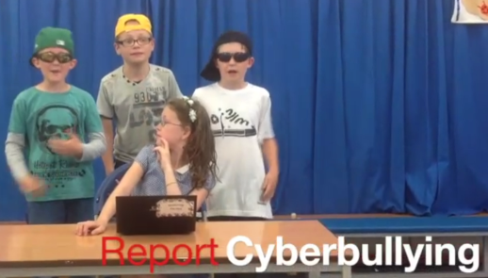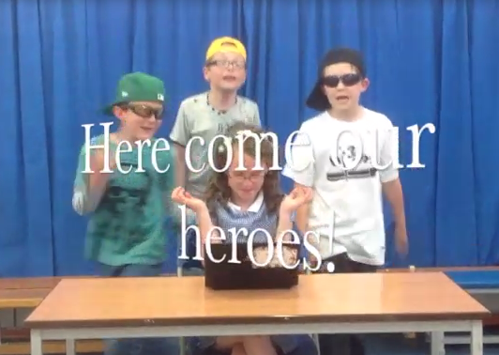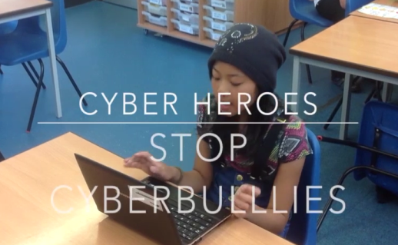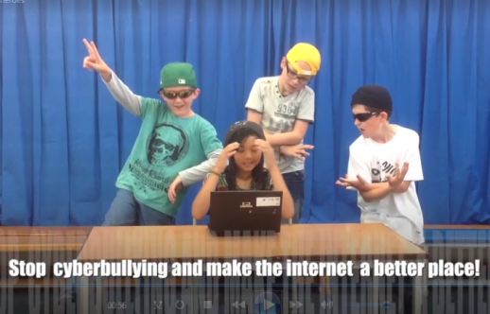

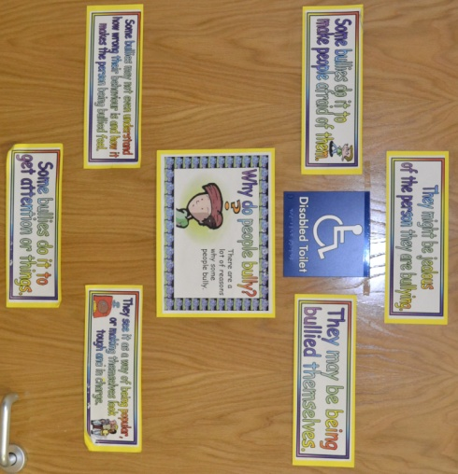

**What children said about the booklet:**

*“I like that I’m in it! It is good that the booklet is made by children we know.” T.Knowles*

*“I like that it has photo stories in it, so it’s not just words. They show you what to do.”* C.Marks

*“I like the - what to do if you know your child is being bullied part - as it helps you to know what to do next.”* O.Kelly

*“I like the part that tells you what to do to stop buying, like keeping a diary...that’s good.”* A.McDonald

“It’s good because if a child is being bullied a parent will know what to do.” E.Geoffrey

“It’s a good idea to show children what it feels like to be bullied, they might think oh, I don’t want to do that.” L. Coburn

The Film Club created short stories about how children can protect themselves from bullying. Mr Western showed these in assembly during

Anti-bullying week.

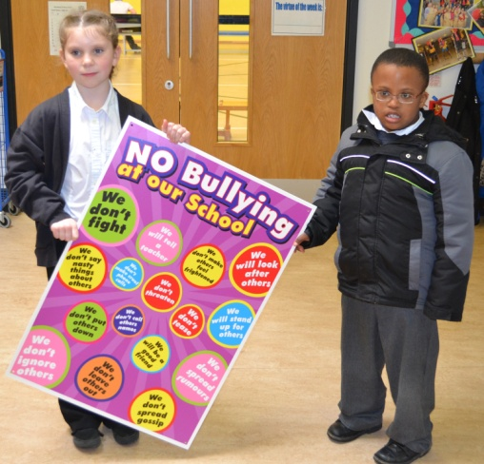

**We will also be** putting up behaviour posters around the school and anti-bullying posters in the playground.

Assemblies will also focus on being a good friend, following the Golden Rules.

We will be inviting speakers into school to talk the children about keeping safe and other related issues.

**The children said:** ‘Can we have areas where we can go if we feel alone at break or playtimes?’

**We said:** This Summer we will be creating a ‘friendship area’ with benches and posters, in front of the MUGA where children can go for support.

Have a look at these websites for helpful tips and ideas:

[www.thinkyouknow.co.uk](http://www.thinkyouknow.co.uk)

[http://www.saferinternet.org](http://www.saferinternet.org/" \t "_blank)