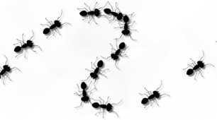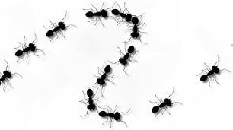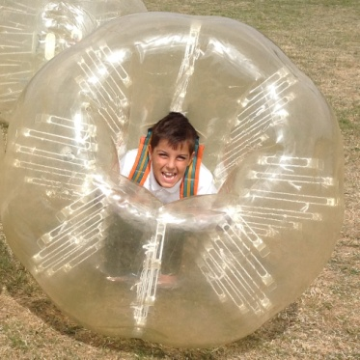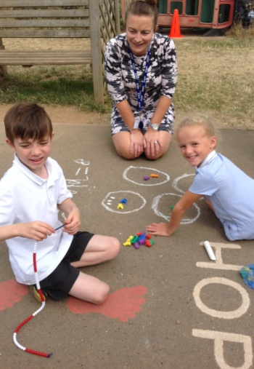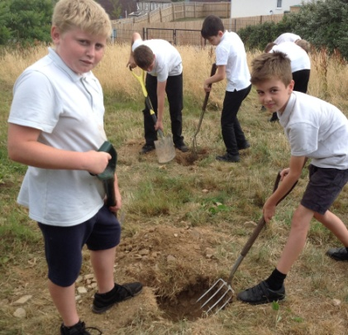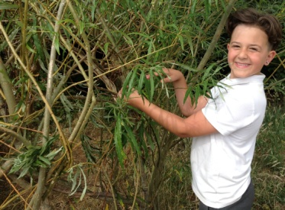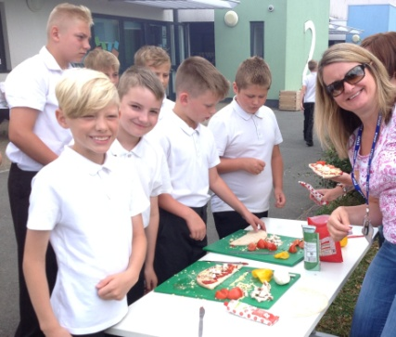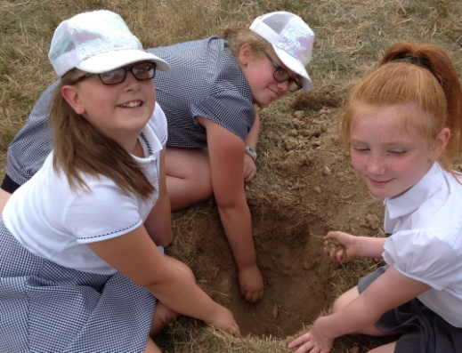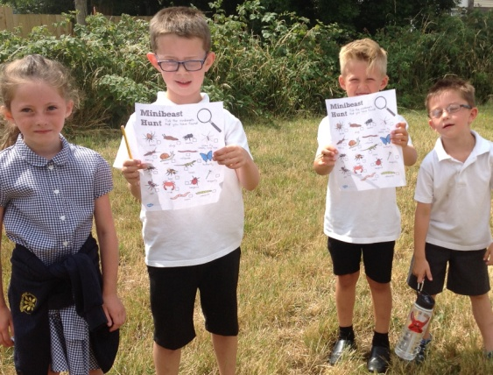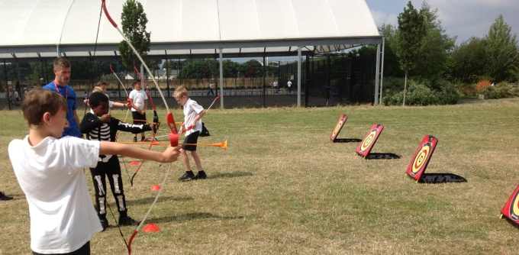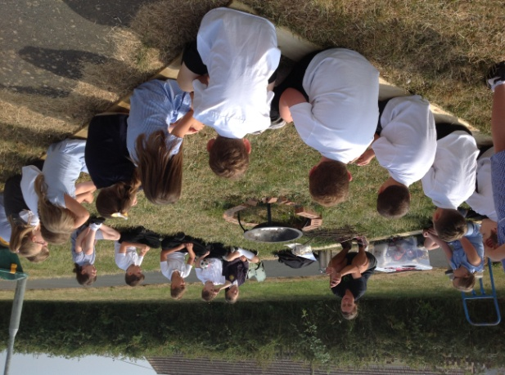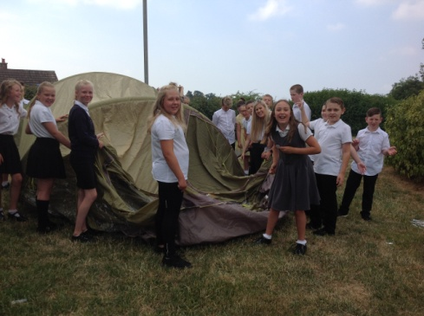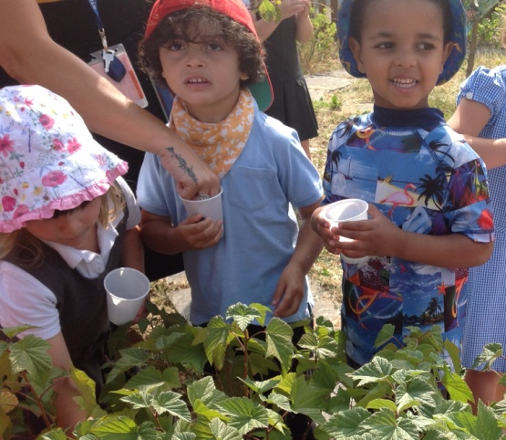

2018

BEECHWOOD’S

Year 5 went Zorbing...

Year 2 did outdoor maths

...and willow weaving.

Year 5 also showed true grit and determination as they successfully dug all ten post holes for the start of the Forest school building on the sports field.

Years 3,4 and 5 played percussion to the parents and the whole school danced with RSVP Bhangra.

Some children tried Archery

Year 3 had a Bushcraft session with Bex House

Year 6 attempted to put up a tent... and cooked pizzas in the cob oven.

Year 1 went on a Mini-beast hunt

Nursery children picked blackcurrants in our fruit garden over the fence.